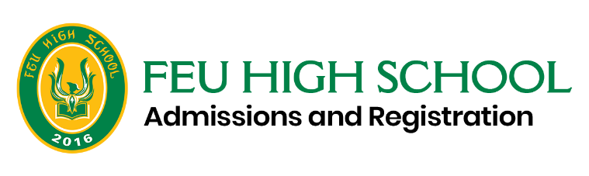
PENDING REQUIREMENT AGREEMENT

I/We, the guardian/ parent of _______________________________________________, applicant for incoming Grade 11 for SY 2021-2022, recognize my/our duties and responsibilities with regard to the submission of all Entrance Requirements to FEU Senior High School.
I/We acknowledge that my/our child’s enrollment is provisional to his completion of the requirements enumerated below, and shall be made official when I/we submit to the school these documents on or before September 10, 2021.
IMPORTANT: Failure to comply with all the admission requirements will invalidate enrollment.
- Original NSO Birth Certificate
- Certificate of Good Moral Character
- Original Copy of Grade 10 Final Report Card
- Others: ___________________________________
_______________________________ _______________________________
Signature over Printed Name of Parent/ Guardian Signature over Printed Name of FEU HS Admissions Staff/Officer

Date Signed: _________________________

___________________________________________________________________________________________________________
Please take note of the submission of documents guidelines below.
1. The student shall place the original copies of the following documents in a long brown envelope:
a. Grade-10 Final Report Card
b. PSA/NSO Birth Certificate
c. Good Moral Certificate
d. ESC Certificate/Certificate of moving up (Include this if the student is a DepEd voucher grantee)
2. The student shall submit to the school the sealed long brown envelope with the proper label (indicating their name and grade and section) through any courier. Here are the shipping details:
a. Ship to Ms. Elaine Relucio, Admissions Officer
b. Contact Number: 8736-0018 or 0936-808-1280
c. Address: Nursing Building Room 202, FEU High School, Nicanor Reyes Street, Sampaloc, Manila.
3. The student must also email the admissions office the following information:
Complete Name, Grade and Section, Contact number, documents submitted, Tracking number, Date of submission). This is for tracking purposes.
4. Submission is until September 10, 2021 only.

